Annual
Drinking Water Contaminants
The sources of drinking water (both tap water and bottled water) include rivers, lakes, streams, ponds, reservoirs, springs, and wells. As water
travels over the surface of the land or through the ground, it dissolves naturally-occurring minerals and, in some cases, radioactive material,
and can pick up substances resulting from the presence of animals or from human activity.

Contaminants that may be present in source water include:

- Microbial contaminants, such as viruses and bacteria, which may come from sewage treatment plants, septic systems, agricultural livestock operations, and wildlife.
- Inorganic contaminants, such as salts and metals, which can be naturally-occurring or result from urban storm water runoff, industrial or domestic wastewater discharges, oil and gas production, mining, or farming.
- Pesticides and herbicides, which may come from a variety of sources such as agriculture, urban storm water runoff, and residential uses.
- Organic chemical contaminants, including synthetic and volatile organic chemicals, which are by-products of industrial processes and petroleum production, and can also come from gas stations, urban storm water runoff, and septic systems.
- Radioactive contaminants, which can be naturally occurring or be the result of oil and gas production and mining activities.

Drinking water, including bottled water, may reasonably be expected to contain at least small amounts of some contaminants. The presence of contaminants does not necessarily indicate that the water poses a health risk. More information about contaminants and potential health effects can be obtained by calling the EPA’s Safe Drinking Water Hotline at (800) 426-4791.

In order to ensure that tap water is safe to drink EPA prescribes regulations which limit the amount of certain contaminants in water provided by public water systems. FDA regulations establish limits for contaminants in bottled water which must provide the same protection for public health.

Some people may be more vulnerable to contaminants in drinking water than the general population.

Important Health Information
Immuno-comprised persons such as persons with cancer undergoing chemotherapy, persons who have undergone organ transplants, people with HIV/AIDS or other immune system disorders, some elderly and infants can be particularly at risk from infections. These people should seek advice about drinking water from their health care providers. EPA/CDC guidelines on appropriate means to lessen the risk of infection by Cryptosporidium and other microbial contaminants are available from the Safe Drinking Water Hotline (800-246-4791).

If present, elevated levels of lead can cause serious health problems, especially for pregnant women and young children. Lead in drinking water is primarily from materials and components associated with service lines and home plumbing. We cannot control the variety of materials used in plumbing components. When your water has been sitting for several hours, you can minimize the potential for lead exposure by flushing your tap for 30 seconds to 2 minutes before using water for drinking or cooking. If you are concerned about lead in your water, you may wish to have your water tested. Information on lead in drinking water, testing methods, and steps you can take to minimize exposure is available from the Safe Drinking Water Hotline or at www.epa.gov/safewater/lead.
System #0220005
April 12, 2018

Quality Report
Drinking Water

2017

Talatha Rural Community
Water District

for the Period of January 1 – December 31, 2017

Our Commitment
We are pleased to present this year’s Annual Quality Water Report. This report is designed to provide you with important information about your drinking water and the efforts made by this system to provide safe drinking water. Our constant and most important goal is delivering a safe and dependable supply of drinking water. We are committed to ensuring the quality of your water.

For more information regarding this report or if you have any questions, please contact the Talatha Rural Community Water District (TRC) office at (803) 652-1381.

Where Does My Water Come From?
Talatha Rural Community Water District’s water source is ground water produced from wells in the Tuscaloosa Aquifer. Our water is monitored daily, and we strive to continually improve the water treatment process and protect our water resources.

Source Water Assessment Plan
Our Source Water Assessment Plan is available at:
http://www.scdhec.gov/environment/water/srcewtrreports.htm
If you do not have internet access, please contact our office at (803) 652-1381 to make arrangements to review this document.

We Want Our Valued Customers to be Informed
To learn more about TRC Water, please attend any of the regular monthly
meetings held on the third Tuesday of each month at 5:30 p.m. at the TRC office, 4 Aspen Court, Aiken and /or
visit our website: trcwaterdistrict.com

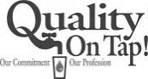
Talatha Rural Community Water District - 4 Aspen Court – Aiken, SC 29803
Phone: (803) 652-1381 FAX: (803) 652-1138 Website: trcwaterdistrict.com

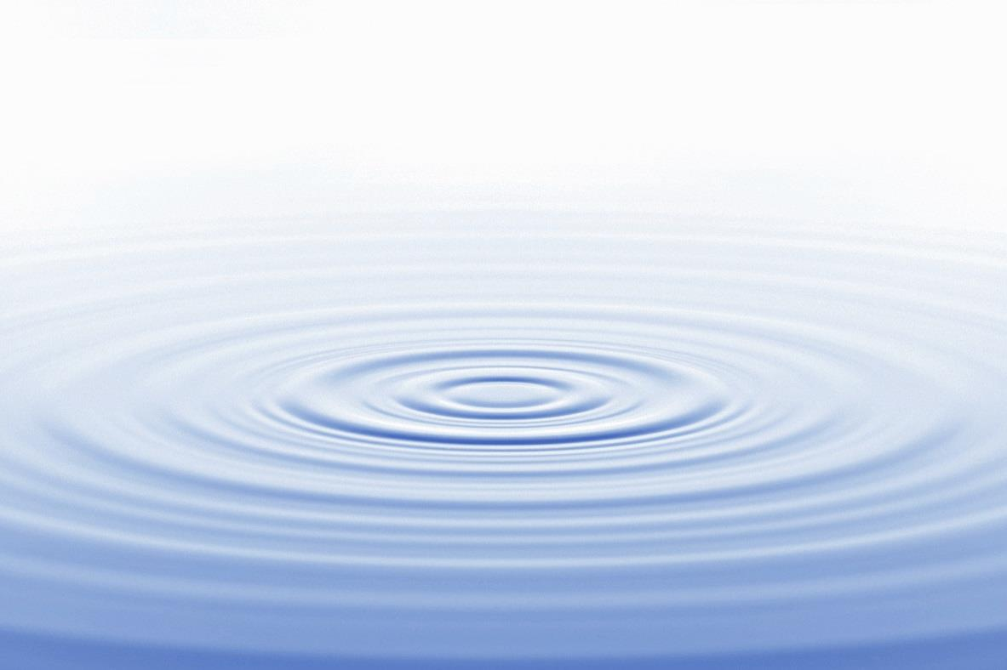
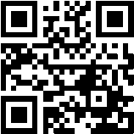
Talatha Rural Community Water District - 4 Aspen Court – Aiken, SC 29803
Phone: (803) 652-1381 FAX: (803) 652-1138 Website: trcwaterdistrict.com

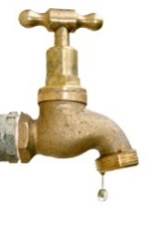
The Talatha Rural Community Water District routinely monitors for constituents in your drinking water according to federal and state laws. The table in this report shows the results of our monitoring for the period of January 1st to December 31st 2017.

DEFINITIONS
In the ‘Test Results’ table to the right, you may find unfamiliar terms and abbreviations. To help you better understand these terms, the following definitions are provided:

Action Level (AL) – the concentration of a contaminant which, if exceeded, triggers treatment or other requirements which a water system must follow.

Action Level Goal (ALG) – the level of a contaminant in drinking water below which there is no known or expected risk to health. ALGs allow for a margin of safety.

Avg – Regulatory compliance with some MCLs are based on running annual average of monthly samples.

Maximum Contaminant Level (MCL) – The highest level of a contaminant that is allowed in drinking water. MCLs are set as close to the MCLGs as feasible using the best available treatment technology.

Maximum Contaminant Level Goal (MCLG) – The level of a contaminant in drinking water below which there is no known or expected risk to health. MCLGs allow for a margin of safety.

Maximum Residual Disinfectant Level (MRDL) – The highest level of a disinfectant allowed in drinking water. There is convincing evidence that addition of a disinfectant is necessary for control of microbial contaminants.

Maximum Residual Disinfectant Level Goal (MRDLG) – The level of a drinking water disinfectant below which there is no known or expected risk to health. MRDLGs do not reflect the benefits of the use of disinfectants to control microbial contaminants.

n/a – Not applicable

N/D – Non-detect

Parts per million (ppm) or Milligrams per liter – or one ounce in 7,350 gallons of water

Parts per billion (ppb) or Micrograms per liter (ug/l) – or one ounce in 7,350,000 gallons of water

Pico curies per liter(pCi/L) – Pico curies per liter is a measure of the radioactivity in water.

As you can see below, our system had no violations. We’re proud that your drinking water meets or exceeds all federal and state requirements. We have learned through our monitoring and testing that some constituents have been detected. The EPA has determined that your drinking water IS SAFE at these levels.

TEST RESULTS

RADIOACTIVE CONTAMINANTS
Contaminant | Collection  Date | Highest  Level  Detected | Range of Levels  Detected | MCLG | MCL | Units | Violation | Likely Source of Contamination
Gross Alpha emitters  Excluding radon and uranium | 2017 | 3.3 | 3.3-3.3 | 0 | 15 | pCi/L | N | Erosion of natural deposits
Combined Radium  226/228 | 2017 | 2.7 | 2.0-2.7 | 0 | 5 | pCi/L | N | Erosion of natural deposits
INORGANIC CONTAMINANTS
Contaminant | Collection  Date | Highest  Level  Detected | Range of Levels  Detected | MCLG | MCL | Units | Violation | Likely Source of Contamination
Nitrate (measured as Nitrogen) | 2017 | 2.3 | 0.79 – 2.3 | 10 | 10 | ppm | N | Runoff from fertilizer use; Leaching from septic tanks, sewage; Erosion of natural deposits
LEAD AND COPPER
Contaminant | Collection Date | MCLG | Action Level (AL) | 90th Percentile | # Sites over AL | Units | Violation | Likely Source of Contamination
Copper | 2015 | 1.3 | 1.3 | 0.026 | 0 | ppm | N | Erosion of natural deposits; Leaching from wood preservatives; Corrosion of household plumbing systems
Lead | 2015 | 0 | 15 | 3 | 0 | ppb | N | Corrosion of household plumbing systems; Erosion of natural deposits
DISINFECTANTS AND DISINFECTION BY-PRODUCTS
Contaminant | Collection  Date | Highest  Level  Detected | Range of Levels  Detected | MRDLG | MRDL/MCL | Units | Violation | Likely Source of Contamination
Chlorine | 2017 | .86 | .2-.86 | 4 | MRDL=4 | ppm | N | Water additive used to control microbes
Trihalomethanes  (TTHMs) | 2017 | 4 | 4.2 – 04.2 | n/a | MCL= 80 | ppb | N | By-product of drinking water disinfectant

